**Type (a) How to run “JAVA File” by using Build Tool “maven”**

1. For Maven we need to install one plugin “maven integration”.
2. Restart the Jenkins.
3. Go to “Manage Jenkins” -> “ go to “global Tool Configuration” -> go to “maven” -> click on “Maven Installations” -> select version -> click on Apply & save.
4. Click on “New-item” -> Select “freestyle Project”.
5. In “Build section”

Select “Invoke top-level Maven Targets”

Choice

Maven version

Goals

1. Click on Apply & Save
2. Click on “Build Now”.

**Type (b) How to run “JAVA File” by using Build Tool “maven” and Host website in another TOMCAT server**

EC2

With

Java & Tomcat

EC2

With

Java & Jenkins & maven

By the help of Jenkins pipeline, we will move war file to Tomcat server.

1. We need to install 2 plugins :
2. Maven integration
3. Deploy to Container ===> for deploy
4. Go to “Manage Jenkins” -> “ go to “global Tool Configuration” -> go to “maven” -> click on “Maven Installations” -> select version -> click on Apply & save.
5. Click on “New Item” -> select “Maven project” -> click on ok
6. In “source code Management” -> select “Git”

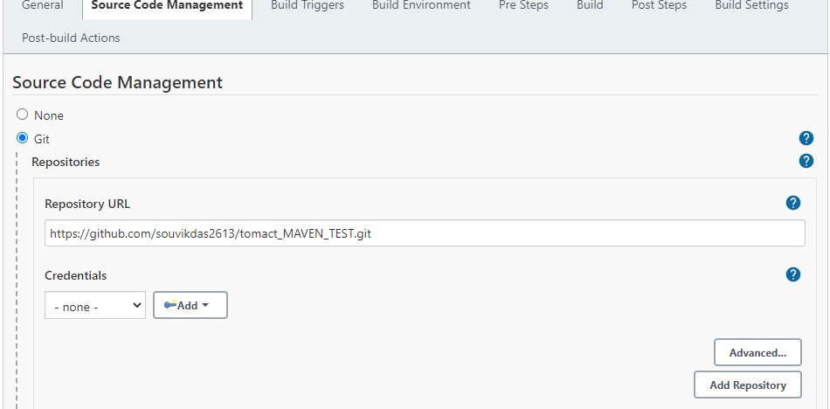

And Branch

1. In “Build Trigger”

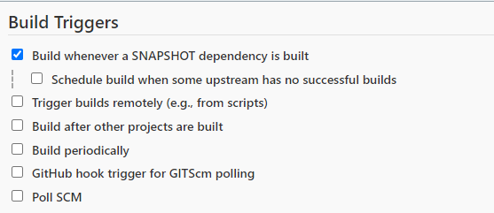

1. In “Build” and “ post steps”

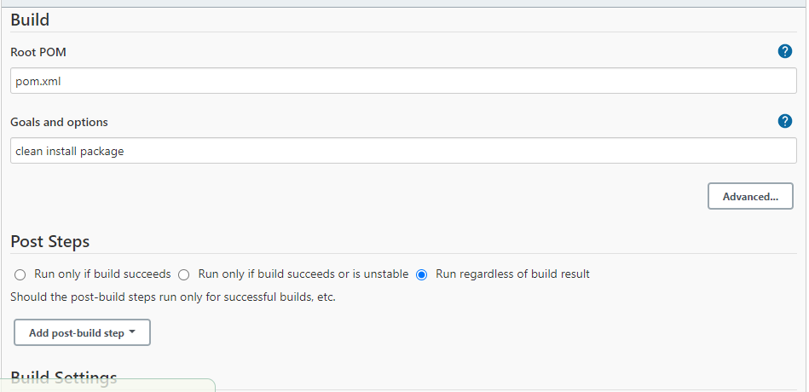

1. In “Post Build Actions”

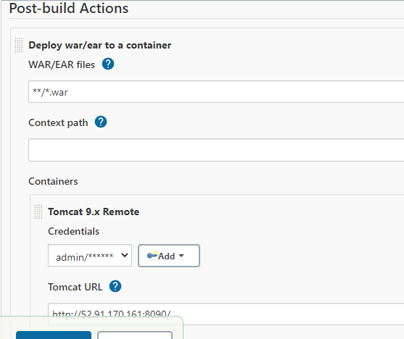

1. Click on apply and save.
2. Check below

